MAT150 Statistics Assignment #7 (Optional) www.helpyourmath.com/150.5

- A restaurant offers five sizes of pizza, three types of crust, and six toppings. How many possible combinations of pizza with one topping are there?

- How many ways can 5 people be lined up to get on a train?

- A lock has five dials. On each dial are letters from A to Z. How many possible combinations are there?

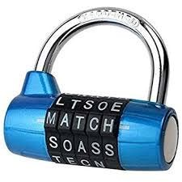

- BMCC ID has 8 numbers.

  - If the same number can be repeated, how many can be made?

  - If the same number CANNOT be repeated, how many can be made?

